**ICT for Wild-life : A technical review**

**Rashmi Pandey, Puja Kadam, Sapan Naik**

**Abstract:**

ICTs are imperative in capturing, processing and distributing the information. The information used and demanded can be put into consideration of institutional requirements as per the perspective of the end users which can improve decision making process. Due to the expansion of ICT technology “Sensor Networks” has come up as a new research area which is possible due to miniaturization of components; development of low cost and low power integrated circuits, MEMS based sensor and efficient wireless communication. One can also monitor the behavior of wildlife in a different way which was not possible through traditional means which also helps reducing chances of conflict. This paper portrays about some approaches that we have made for protection and management of wildlife. Wildlife management engrosses the application of scientific knowledge and technical skills for protection, conservation and management of wildlife and their habitat.

Key words: ICT, wild life, wireless sensor networks, GPS monitoring

1. **INTRODUCTION**

India has affluent and speckled fauna. No region can compete with India in terms of its culture, climate, vegetation and wildlife. There are about 75,000 species of animals of which 340 are mammals, 1200 birds, 420 reptiles, 140 amphibians, 2000 fishes, 50,000 insects, 4000 mollusks and the other invertebrate. Fauna and flora of India are highly diversified into countless beautiful and varied forms.

All living organism (e.g. plants, animals, microorganisms) are included by the wildlife in their natural habitats which are neither cultivated or domesticated nor tamed. Certain significance of wildlife are as follows:

1. *Ecological Balance:* Wildlife maintains balance of nature through-  
   (a) Regulation of population using different species.  
   (b) Food-chains or passage of food and energy through series of populations comprising of producers, consumers and micro-organisms.   
   (c) Natural cycles or circulation of inorganic nutrients between biotic and a biotic environments.
2. *Gene Bank:* The Wildlife serves as a gene banks for breeding improved varieties in agriculture, animal husbandry and fishery. High-yield and disease –and-stress resistant varieties that forms the backbone of modern agriculture is developed by plant and animal breeders. Hence, gene bank maintenance is essential.
3. *Plant Propagation:* Pollination in certain plants is performed by wild animals like birds; insects etc. that ultimately help in plants propagation, which is very crucial.
4. *Cleaning of Environment:* Scavengers decomposes wild animals (like vultures, eagles, jackals etc.) as well as micro-organisms, which feed upon dead animals, convert them into special nutrients and release energy back to the nature increasing fertility of the soil. If the cleaning of the environment is not done properly, the fate of this planet will be, can be assumed.
5. *Scientific Importance:* It is beneficial for research purposes and studies of anatomy, physiology, ecology, evolutionary aspects.
6. *Soil Erosion:* It is prevented by plant cover, litter, mixing of litter by movement of wild animals and conversion to spongy humus by micro-organisms.
7. *Control of Pollution*
8. *Perennial Fresh Water*
9. *Maintenance of Climate*
10. *Experimental Animals - Monkeys, Rabbits, Guinea-pigs, Rats etc.*
11. *Economic Importance:* Timber, firewood, paper, gum, resins, tannins, several drugs, essential oils, spices, silk, honey, hair, feathers, guano (the dung of sea-fishes used as manure or the manure made from fish), leather, musk, ivory etc. are obtained from wildlife. Economically, it is benefited from: Tourists, Exports, Hide, ivory etc. after death of wild animals; despite the fact that now-a days it is legally banned and not in practices.
12. *Potential uses:* Recently cultivated/domesticated plants and animals are derived from wildlife; new foods, beverages (A beverage is a type of plant product used by everyone daily which contains an alkaloid called caffeine having the simulative action in the human body e.g. tea, coffee, cocoa etc.), drugs and other useful products may be obtained in future from wildlife [1].

Developments in Information and Communication Technology (ICT) can allow one to monitor the behavior of wildlife in a way not possible earlier through traditional means and help reducing chances of conflict [2]. ICT (information and communications technology - or technologies) is a term that includes any communication device or application, encompassing: radio, television, cellular phones, computer and network hardware and software, satellite systems and so on, as well as the various services and applications associated with them, such as videoconferencing and distance learning. ICTs in education, health care, or libraries, forestry and wildlife are often spoken in context of ICT.

1. **LITERATURE REVIEW**

With the development of ICT technology an area of research called “Sensor Networks” has emerged. This has been possible due to miniaturization of components; development of low cost and low power integrated circuits, MEMS based sensor and efficient wireless communication. Most of these developments have taken place due to commercial demands but have led to sensor networks being a viable solution in many application areas. Intelligent power saving devices on the body of the animal can be integrated which can monitor not only the migration pattern and activity but also microclimate through which animal is moving. These data will be available to the researchers at their workplace through the wireless communication links. Many more possibilities have opened up to understand the animal behavior in an efficient manner by the researchers and improve wildlife conservation effort along with developmental activities [2].

It is difficult and costly to monitor and manage species depending on reliable population estimates for cryptic large vertebrates that live in forested habitats. Recently developed camera trapping techniques have already been shown to be an effective means of making mark-recapture estimates of individually identifiable animals (e.g. tigers). Camera traps also provide a new method for surveying animal abundance. Through computer simulations, and an analysis of the rates of camera trap capture from 19 studies of tigers across the species' range, number of camera days/tiger photograph correlates with independent estimates of tiger density. This statistics is particularly useful for estimating the population density of species that are not individually identifiable but it does not rely on individual identity. To end with we compared observed trapping rates and the computer simulations to estimate the minimum effort required to determine that tigers, or other species do not exist any more in an area, which is ultimately a measure that is critical for conservation planning [4].

RACHEL et. al had designed and implemented a reactive, event driven network for environmental monitoring of soil moisture and evaluates its effectiveness. Reactivity to the environment is a novel feature, which can be estimated when rain falls and soil moisture is changing rapidly, measurements are collected frequently, whereas during dry periods, between rainfalls, measurements are collected less often. Field trials demonstrate the reactivity, robustness, and longevity of the network [5].

Antonio-Javier at. al proposed and studied a WSN based system for generic target (animal) tracking in the surrounding area of wildlife passages built to establish safe ways for animals to cross transportation infrastructures. On top of it, using video sensors connected to strategically deployed nodes we can allow target identification. The system has been evaluated for the particular scenario of wildlife monitoring in passages across roads. Various schemes have been simulated for this purpose to identify the best network operational parameters. Moreover, a novel prototype, provided with motion detector sensors, has also been developed and its design feasibility demonstrated [6].

1. **ICT APPLICATIONS**
2. *GPS based tracking system*

Traditionally human observers have played essential role in migratory pattern of wild animal by the wildlife researchers.GPS and satellite based radio collars have come into existence with the expansion of ICT. However, these are very expensive and due to this number of animals that can be monitored using this technique is very small.

In this paper [2], author is developing a sensor network based system using only terrestrial peer-to-peer communication for the purpose of monitoring movement of animal. On the neck of it in the form of collar, we have tested a proof-of-concept. This device also includes small embedded computer along with GPS and wireless communication device. Moreover, depending upon the parameters we wish to monitor, device can be equipped with numerous sensors. For instance, if we are monitoring microclimate (Ambient Temperature, Humidity and Light) and animal head movements, this same information will not be available in a similar work called “Zebranet”.

The movement of the animal (using GPS) and other sensor data is periodically recorded and stored on the device in a flash memory. Through peer-to-peer communication, the stored data is spread to other animals carrying compatible nodes. All the data that has been accumulated through its own measurements or other data that comes through indirect/direct exchange with other animals are transferred if any of the animals comes in communication range with a fixed mobile base station. This facilitates wildlife researchers getting information about the movement and other data of the group of animal at their convenience.

Hardware Details: An ATMEL ATMega128L microcontroller is embedded on the body of the animal and is connected to Lassen IQ GPS Receiver with embedded antenna for collecting position information periodically. . A flash memory (AT45DB321B) of 32 Mbits is used to store data being collected. Microclimate information would be collected through Temperature, Humidity (Sensirion SHT11) and Light sensor (TAOS TSL2561). Using temperature, humidity (Sensirion SHT11) and Light sensor (TAOS TSL2561) microclimate information can be collected. An accelerometer can be added to monitor the head movement to find the activity animal can be engaged this work can be done.



Figure 1 GPS based tracking device [2]

If sunlight is available the device is power through a battery with solar photovoltaic films to recharge. Device would be running an operating system to schedule its various tasks. It is having a RTC to wake the device periodically as if most of the time device would be sleeping. At periodic interval device can be programmed to collect GPS and other sensor data. Moreover, presence of other animals in communication range and exchange of data can be checked periodically. RTC and the various devices can be synchronized through GPS using timing information.

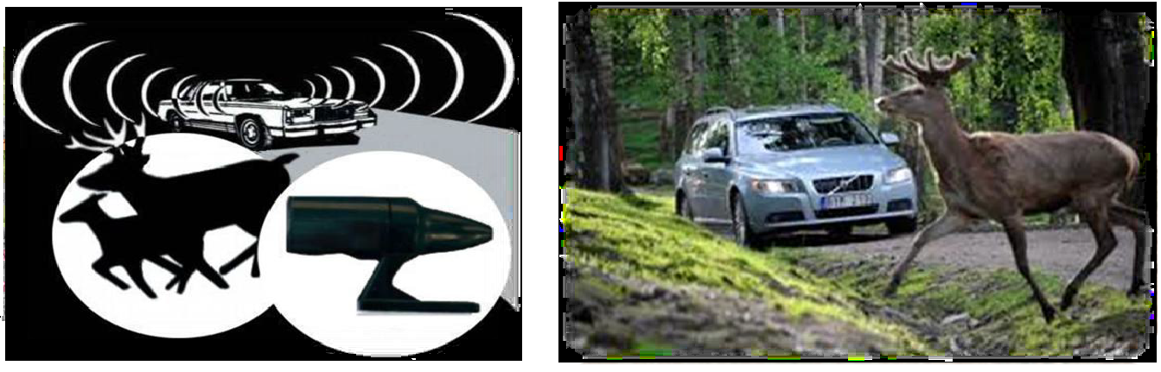

Figure 2 Vehicle Collisions prevention in Wildlife [6]

Mobile GPS units have been outfitted with buttons that allow users to select when moose or deer are seen along roads, either alive or dead. Accurate data regarding the time, date and location are stored in the unit and downloaded and used for further mapping and analysis. Out of a unit ten of them are distributed to local truck drivers, who have been recording data along highways heading out of Prince George, USA to the north, south, east, and west since July. To collect more data researchers are willing to continue their work with local transport companies.

1. *RFID*

The procedure developed above is based on GPS measurement of position which is not suitable for small animals. Battery weight turns out to be very large than desired one for small size animal, where one may have to limit device size on the body of the animal to be in the range of 25-30 Gms as locating position using GPS consumes too much power. Consequently, one has to devise a new way for monitoring small animals over a limited area like WII campus.

One alternative of performing this is to put a RFID tag on the animals and identify them when they move in the range of a RFID tag header. Dense deployment of readers is required because the range of RFID reader is very limited. This method is not suitable for small animals moving in a wide area and no microclimate can be recorded and studied is the fact. Vehicles with much larger weight than permissible for monitoring small animals can be identified by the long range RFIS designed systems.

We have proposed and tried to set up a grid of transmitting/receiving stations and put an active node on the body of the animal which can be seen from the figure 2 in which we have shown a representative set of receiving stations (P1 to P9) which forms 4 different cells. Depending on the location of the animal the four of the stations would be communicating with the animal (shown as 'A' in figure). Microclimate parameters as well as transmission of signals to communicate with the receiving stations can be sensed when the device is embedded on the body of the animal. We are assuming here that the receiving stations would have power supply so we are not worrying about the energy consumption issues on the receiving stations. Conversely, sense energy constraints and challenge of this work would maximize the life time of the device without charging the battery when the device is embedded on the body of the animal. Now we have two possible methods of localizing the animal.

First one is based on the estimated distance obtained through signal strength received by the neighboring receiving stations and mapping of signal strength can be carried out by given transmitter which will be used to invert the signal strength measurements to a location with respect to the grid point. Second, depends on measuring the angle of the animal with respect to the various receiving poles which will help to localize the animal. Scanning directional antenna on each of the poles can be set out to identify the angle. Still scanning antenna should be monitor on electronic switching of a multi antenna system or not is still to be analyzed.

In addition, we would be recording microclimate (temperature, humidity and light) through which the animal moves and would transmit this information to the receiving station, once the communication is established. A critical part of the information would be to determine when the animal is hybernating and for what period of time it remains in that condition.

*Hardware Details:* The device embedded on the body of the animal would consist of an Atmel AVR microcontroller, a 2.4 GHz Zigbee transceiver, Flash memory, microclimate sensor and battery which is supported by a RTC (Real Time Clock with battery backup). A solar film can be added for recharging the device and keep the battery weight low which depends on whether animal comes out in the sun or not and sporadically device would try to communicate with the receiving stations. Average speed of the animal and residual energy in the battery would be decided periodically and the receiving stations will form a grid.

Each station would have a Atmel AVR microcontroller, a flash storage unit and a 2.4 GHz RF transceiver with appropriate set of antenna. In addition some of these would also monitor local microclimate data. These nodes would be powered by campus street light power supply and would not have a energy constraint like that of the device on animal.



Figure 3 GPSless tracking system for small animals. 'A' is the animal and P1...P9 is receiving stations [2]

The transceiver would always be in a listening mode. These devices would form a multi hop network and would eventually link to the Wi-Fi network of the WII campus and would be able to transmit data collected to a server [2].

1. *Image sensor network*

Traditionally movement of animals such as tiger/lion which move through well defined trail is done using camera placed at strategic locations. Currently WII uses film based camera with PIR detector, which is placed across the trail. As the animal passes by the camera is triggered and takes a picture. The cameras are placed in the evening and by morning they are collected. A large number of cameras are used for this purpose and in addition to it being cumbersome to deploy and collect it back; they are also prone to theft.

We are developing a set of cameras which would get triggered by animals passing by and stored picture would be transmitted through wireless link. To start with we will be using a GPRS modem to transmit the picture in the WII campus but later on we would connect a Zigbee transceiver and use a Zigbee/GPRS gateway to transmit the picture as mobile signals would not be available in the forest area. The cameras would form networks to make optimal utilization of the network at the same time they would keep track of the animal’s movement to prepare themselves better.

*Hardware Details:* We will be using an image sensor module with digital output and compression capability based on Omni Vision OV640/8 VGA Color Digital image sensor with OV528 JPEG compression chip. This module can take images both video and still up to 640x480 resolutions. This will be combined with KC7783 PIR Detector Module to detect the motion of the animal up to 10 feet away to trigger the camera.



Figure 4 Camera device for tracking animals on trail [2]

The device would be integrated with an ATMega128 microcontroller and a GPRS modem to transmit pictures through mobile network to base computer. Figure 3 shows the various components for this device. We will also consider the possibility of splitting the system in two parts for reducing the size of camera device, which can be placed near to the trail and the other part for long range communication little farther off.

1. *Camera Traps*

In the early 1900’s camera-traps have been used for documentation of wildlife. Camera trap technology are applicable in population dynamic studies of wild animals which are cost effective and are used in high-density animal habitats. Below given are collections of random pictures obtained with camera traps to estimate the Asian Elephant population structure (age and sex) in the area under study.

The data collected and processed here qualifies to be “opportunistic” as the usage and placement of camera-traps were arbitrary since the purpose was only to test the equipment in the field and the analysis is based on no sampling, protocol or design efforts and no particular planning.

The usability of the camera trap technique in elephant age and sex classification would be emerged if any result emerges through the random approach. This research could be still continued for evaluating the plan of setting the cameras, sampling design, protocol and efforts if no conclusion is drawn. This has been the first ever such approach and it was carried out in places where densities of elephants are known to be reasonably high.

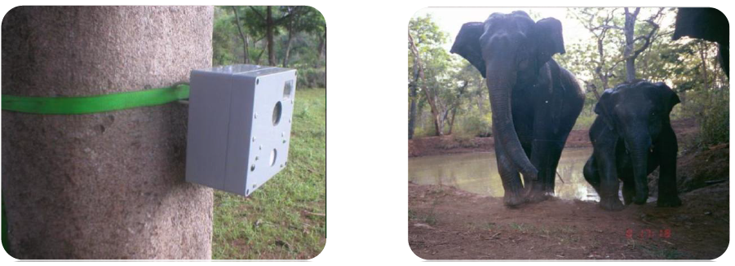

Figure 5 Camera trap in elephant leg [6]

1. *Smart Collar*

Collars on big cats or other animals are put by wildlife managers to track their whereabouts. Frequently movement and the extent of home range can be identified by these collars. Many new things can be analyzed using “Smart Collars”

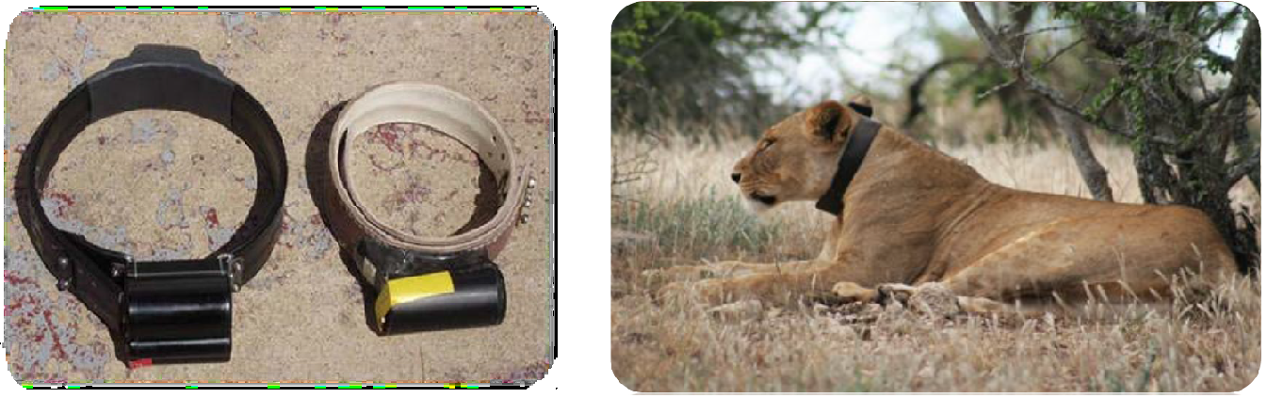

Figure 6 Smart collar on lion's neck [6]

Whether a cat is doing something, is he sleeping? Is he stalking? Can be identified by these new collars using recent developmental stages. Different questions like was his hunt successful and even what he had for dinner scientists will be able to answer with the help of new devices.

Store of data points that documents specific activities are in the progression by wildlife biologists and wildlife veterinarians. Certain movements that looks electronically are recognized with the help of specially trained mountain lions; trained with rewards based training programs of course, biologists and vets have been captured. The collars, equipped with GPS and accelerometers, recognize the electronic signature of these movement data points.

1. *SKY-EYE*

Previously unreachable areas and safe view of illegal activities on the ground are accessible by “Eye in the sky” given by UAV. UAV serve as deterrent and it also help to track and trace animals.

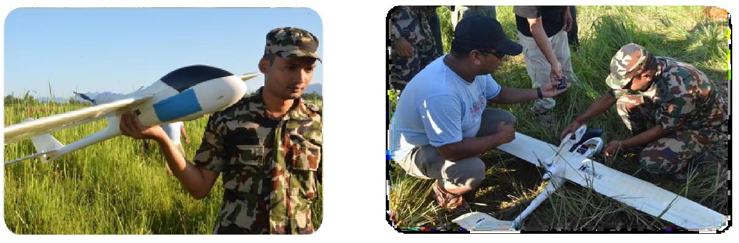

Figure 7 Programming a UAV in Nepal [6]

The GPS-enabled FPV Raptor model planes are low cost and light enough to be launched by hand whose battery can be recharged in about half an hour. They film the ground below with a still or video camera and can fly a pre-programmed route of about 18 miles at a maximum elevation of 650 feet for up to 50 minutes.

1. **CONCLUSION AND FUTURE SCOPE**

Developments in Information and Communication Technology (ICT) can allow one to monitor the behavior of wildlife in a way not possible earlier through traditional means and help reducing chances of conflict. In this paper we have reviewed different approaches on using sensor network technology to monitor wildlife in ways, not possible earlier.

In future, ICT will have an enormous effect on tomorrow's society, surprisingly little research has been conducted regarding its future environmental consequences. Most of the work that has been done has reached one of two opposing conclusions: either ICT will bring only good things, from solutions to world hunger, the elimination of all transportation problems and a revitalized democracy Or it will bring nothing but problems, accelerating resource consumption, introducing new toxic materials and resulting in greater inequity by introducing a digital divide that will worsen the already unequal distribution of wealth and influence.

1. **REFERENCES**
2. Ashish Patel, Importance of wildlife in india  [Online].

Available:<http://www.indiastudychannel.com/resources/141853-IMPORTANCE-OF-WILDLIFE.aspx>, Date: Nov. 23,2014.

1. Ranjan and Prabhat, "Applications of ICT to wildlife preservation efforts in India,"*Proceedings of First International Conference on ICT Solutions for Socio-Economic Development* (ISED), 2007.
2. Margaret Rouse, ICT-information and communications technology or technologies [Online].

Available:http://searchcio.techtarget.com/definition/ICT-information-and-communications-technology-or-technologies, Date: Nov. 23, 2014.

1. C. Carbone *et al.*, “The use of photographic rates to estimate densities of tigers and other cryptic mammals,” *Animal Conservation*, pp 75-79.,2001. DOI: 10.1017/S1367943001001081.
2. Cardell-Oliver and Rachel, "A reactive soil moisture sensor network: Design and field evaluation,"*International journal of distributed sensor network*s, pp 149-162, 2005.
3. Sagar Patel, “Technology for wild life”, An article(Unpublished).
4. **AUTHORS PROFILE:**

|  |  |
| --- | --- |
| Ms. Rashmi Pandey | Ms. Rashmi Pandey received her M.Tech in CE in 2014 from Uka Tarsadia University Bardoli, Gujarat and B.Tech in CSE in 2012 from Gujarat Technical University Ahmedabad, Gujarat. She is working as an Assistant Professor in Department of Computer Engineering and Information Techonolgy, (CGPIT), Bardoli. She has published a research paper in international journal and 4 papers in international conference. Her research interests include image processing, machine learning, |
| **Ms. Puja Kadam** | Ms. Puja Harish Kadam has completed her bachelors in Medical Technology in year 2007 and was awarded Master Degree in Computer Applications from VNSGU. She is currently working as Assistant Professor at Department of Computer Science & Technology, UTU. She has published one research paper in International Journal of Computer Applications. Her area of interest are Business Intelligence, Decision Support System and Information Security. |

|  |  |
| --- | --- |
| Mr. Sapan Naik | Mr. Sapan Naik is an Assistant Professor at Department of Computer Science & Technology, UTU. He has published several research papers in National and International Journals of Computer Applications.  He is pursuing his Ph.d. from UTU and his area of interests Digital Image Processing and Soft computing. |